Campaign Overview

Overview

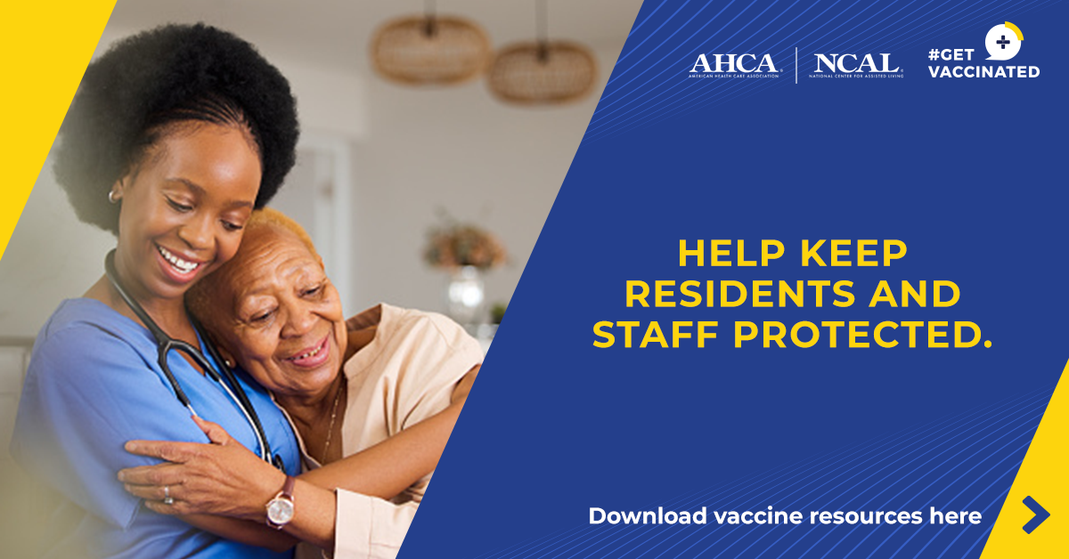
As we enter the fall and winter months, protecting our most vulnerable population in long term and post-acute care is crucial. Respiratory viruses like COVID-19, flu, and RSV pose serious risks.

AHCA/NCAL’s #GetVaccinated campaign supports long term and post-acute care providers by offering resources designed to help facilities lead effective vaccination efforts.

The Risk Less. Do More. campaign by the U.S. Department of Health and Human Services complements these efforts nationally, focusing on increasing public confidence in vaccines and encouraging higher vaccination rates.

Together, these campaigns emphasize the importance of vaccination, align messaging across national and local levels, and work to protect the health and safety of residents, staff, and communities during this critical time.

#GetVaccinated (Long Term Care Focus):
- The primary focus is supporting providers with tools, resources and information needed to address the heightened risk from respiratory viruses faced by seniors and immunocompromised individuals in long term care settings.
- A comprehensive strategy is emphasized, combining prevention, testing, vaccination, and treatment to ensure the safety of residents and staff.
- Resources are available at getvaccinated.us.

Risk Less Do More (Public Education):
- The campaign aims to improve public understanding and confidence in vaccines, addressing widespread misinformation.
- Focuses on encouraging preventive measures, particularly vaccination, to reduce the severity of illnesses.
- Learn more at RiskLessDoMore.hhs.gov.
KEY Messages & Talking Points
Key Messages & Talking Points for Speaking with the Media

1. Proactive Protection for Vulnerable Populations

Importance of Vaccination:
- "As we enter the fall and winter seasons, we are prioritizing vaccinations for residents and staff. With COVID-19, flu, and RSV posing significant threats, especially to older adults and those with compromised immune systems, our proactive measures are essential."
- "Vaccination remains the most effective strategy to build immunity, reduce severe illness, and prevent hospitalizations and deaths among vulnerable populations."

2. Comprehensive Vaccination Strategy

Comprehensive Preparedness:
- "We have adopted a comprehensive approach to combat respiratory viruses, seamlessly integrating vaccination, infection prevention, testing, and timely treatment into our care protocols."
- "Our primary objective is to ensure a safe environment for both residents and staff by implementing every necessary precaution to prevent the spread of these viruses."

3. Empowering Through Education

Utilizing AHCA/NCAL’s #GetVaccinated and HHS’s Risk Less. Do More. Resources:
- "AHCA/NCAL’s #GetVaccinated campaign offers essential tools to help us communicate the importance of vaccination effectively, ensuring that residents and staff are well-informed and prepared."
- "HHS’ Risk Less. Do More. campaign complements these efforts by offering additional resources aimed at boosting public confidence in vaccines and encouraging preventive measures, enhancing our collective ability to protect our vulnerable populations."

Engaging Residents and Families:
- "Effective communication with residents and families is crucial to address any concerns they may have."
- "Maintaining open dialogue and providing clear, accessible information can help build trust and increase vaccinations."

4. Strengthening Community Health

Collaboration and Partnerships:
- "We are partnering with health agencies and stakeholders to streamline vaccine access in our for facilities, ensuring vaccines are readily available and administered efficiently."
- "By working together, we can help protect our residents and staff members during the respiratory virus season, contributing significantly to the overall health of our communities."

5. Leadership in Public Health

Monitoring and Reporting:
- "We are closely monitoring vaccination rates and reporting progress."
- "Ongoing data collection and sharing are crucial for refining strategies and maintaining high vaccination coverage, reinforcing our contribution in public health."

Continuous Education and Advocacy:
- "Ongoing education and advocacy are essential to sustaining vaccination efforts. We must continue to promote vaccination to maintain momentum and ensure lasting protection for everyone especially our most vulnerable residents."
- "Vaccines play a critical role in preventing severe illness, especially as new vaccine recommendations become available."

QUESTIONS & ANSWERS
The following questions and answers can help providers with inquiries from the press during the season.

Question: What is your facility doing to ensure high vaccination rates among residents and staff?

Response: "We’ve implemented a comprehensive vaccination strategy, combining education to each resident about the value of the vaccine, easy access to vaccines, and ongoing communication. By leveraging AHCA/NCAL's #GetVaccinated resources, we're ensuring that everyone understands the critical importance of vaccinations and has the support they need to get vaccinated."

Question: How are you addressing concerns from residents or staff who are reluctant about vaccines?

Response: "We seek to understand their reluctance and focus on open communication, providing clear, science-backed information. We use educational materials from #GetVaccinated and “Risk Less. Do More.” campaigns to address concerns and have found that open dialogue significantly increases trust and vaccine uptake."

Question: What steps are you taking to prevent outbreaks if vaccination rates are not as high as expected?

Response: "We’ve adopted a multi-layered approach that includes rigorous infection prevention protocols, regular testing, and access to treatment options. Vaccination is a key element, but we ensure other measures are in place to protect everyone in our facility."

Question: How are you ensuring that your staff follows all safety and hygiene protocols consistently?

Response: "We emphasize strict adherence to CDC guidelines on infection control, including hand hygiene, mask-wearing, and proper use of PPE. Continuous training and monitoring ensure that our staff is always prepared and compliant with safety protocols."

Question: Are there any areas where your facility could improve its preparedness for the upcoming respiratory virus season?

Response: "We are always looking for ways to improve. We regularly assess our protocols and remain flexible, ready to adapt to new guidelines or emerging challenges. Our focus is on continuous improvement to keep our residents and staff safe."

Question: What measures is your facility taking to ensure that you are doing everything possible to protect your residents and staff during the fall and winter months? Are there areas where you think more could be done?

Response: "Our facility is fully committed to protecting our residents and staff with a comprehensive approach that includes vaccination, prevention, and timely treatment. We continually assess our efforts, adapt as needed, and ensure open communication to keep everyone safe and informed.

