Dear << Test First Name >>,

The past few years have been devastating for healthcare workers, and many of us don’t feel like our old selves as we attempt to move forward. Now more than ever, it’s important that we take care of each other and ourselves.

That’s why the Emotional PPE Project was created -- to address the need for emotional support of healthcare workers. The organization has been featured on The Today Show, NPR’s All Things Considered, and in JAMA, Forbes, and more. Our mission is simple – take care of healthcare workers who have done so much to take care of the rest of us, especially over the last few years.
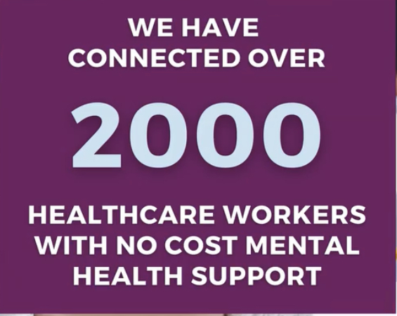
The Emotional PPE Project is a grassroots nonprofit collective of volunteer health professionals dedicated to providing free, confidential, and professional emotional support to healthcare workers in their time of need. We have connected thousands of healthcare workers to volunteer therapists across the nation and continue to do so every day.

At EmotionalPPE.org, any worker in a healthcare-related can make direct contact with any of the 700+ volunteer therapists in the directory and receive emotional support. Residents, physicians, skilled nursing home staff, nurses, and EMTs are only a few examples of the types of healthcare workers the Emotional PPE Project serves currently.

Here any healthcare worker is eligible.
Confidential. No cost. No insurance.
We’ve Got You.

Access the directory today or share the website with a colleague who may need support.

Learn more today at EmotionalPPE.org

